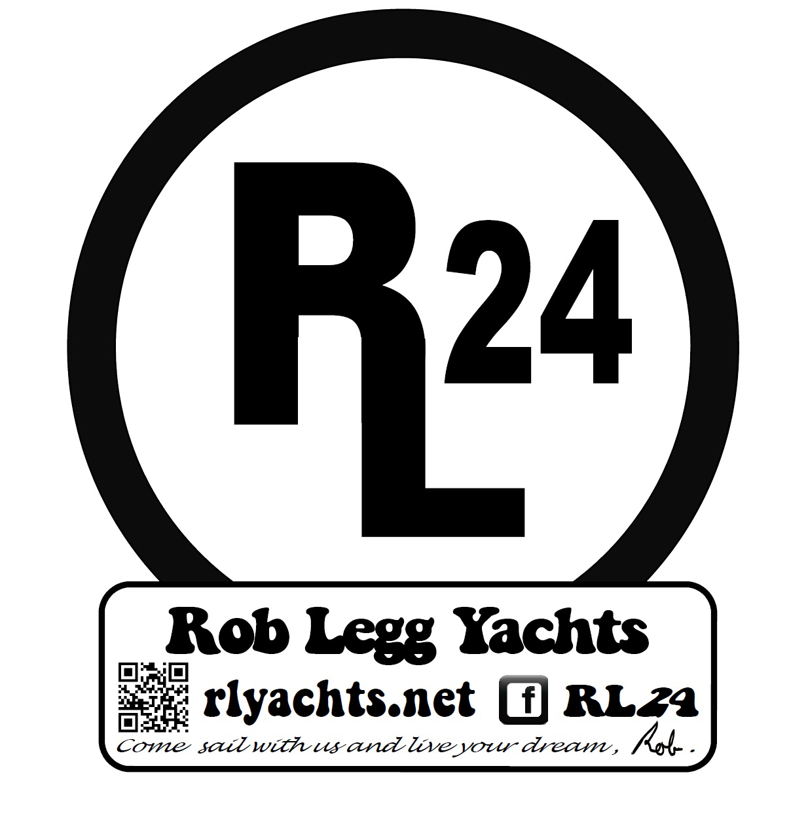 | MEMBERSHIP INVOICE  RL24 OWNERS ASSOC. OF AUSTRALIA Inc.  A 0045403P ABN 75 905 426 014

Membership Subscription / Renewal to the RL24 Owners Association of Australia Inc. for the 2022 / 2023 season is now due and payable. The membership year starts 1st July and concludes 30th June annually.

Please select your membership category by placing a tick in the category box selected.

FULL MEMBERSHIP – 1 YEAR | $40-00
FULL MEMBERSHIP – 3 YEAR | $90-00
ASSOCIATE MEBERSHIP | $15-00

Email this completed Membership Form to: rl24owners.association@gmail.com
and pay your membership fee by direct deposit into:

Account Name: RL24 Owners Assoc. of Australia Inc.
Bank: Commonwealth Bank
BSB: 063-510
Account Number: 1013-5552. (Please include your Boat Name as Reference)

MEMBERSHIP DETAILS
Name:
Address:
Regular Crew?
E-Mail
Phone:
Mob:
Boat Name:
Hull Colour:
Top sides: |  |  | Home State:
Drop or Swing Keel |  |  | Mk. 1, 2, 3 or 4?
Club Usually Sailed At? |  |  | Sail Number:
Website: www.rlyachts.net Facebook: https://www.facebook.com/RL24Sailing/

